Name: Jack Polk
Date: 5/19/2019
16.06 Picture Lab Worksheet
Directions: Make note of your responses to the following questions as you work through the activities and exercise in the lesson.

Activity 8 Exercise Results

- Paste the image that is the result of calling the second copy method that adds parameters to allow you to copy just part of the fromPic.

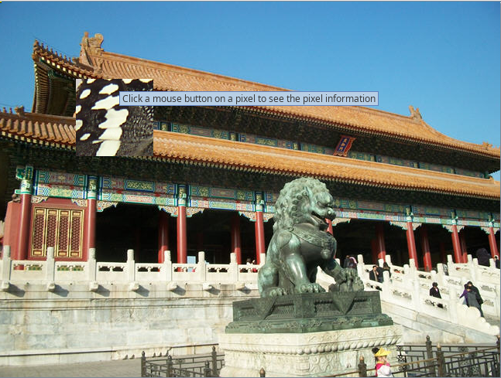

- Paste the image that is the result of calling the myCollage method.
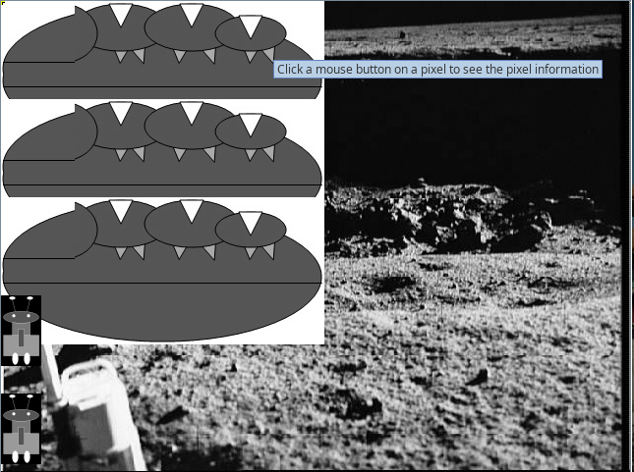

Activity 9 Exercise Results
- Paste the image that is the result of calling the edgeDetection2 method.
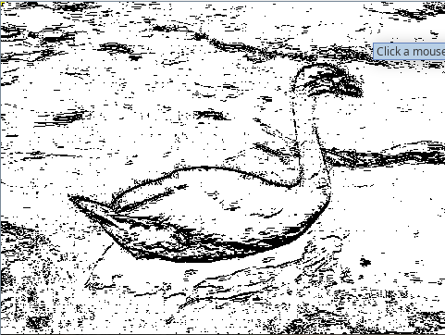

- Think about and propose another algorithm for edge detection.
For another edge-detection algorithm, I would most likely use the same concept of using color distances but use a diagonal traversal of the picture along with the already performed vertical and horizontal traversals.

